CURTIN ISAD 3000 · PROJECT PORTAL
Deployment and Administration Guide
Curtin ISAD 3000 Project Portal
Project | Curtin ISAD 3000 Project Portal
Document ID | CP-DAG-001
Version | 1.2
Date | 25 October 2026
Author | Darren
Status | Draft for review
Classification | Internal

Practical steps to run, configure and maintain the Curtin ISAD 3000 Project Portal: settings, accounts and approved lecturers, lesson management and storage, the maintenance notice, deployment, checks and troubleshooting.

Document Control

Document information
Document title | Deployment and Administration Guide
Document ID | CP-DAG-001
Project | Curtin ISAD 3000 Project Portal
Document type | Handover guide for administrators
Version | 1.2
Author | Darren
Date issued | 25 October 2026
Status | Draft for review
Classification | Internal
Intended audience | Project owner and administrators

Revision history
Version | Date | Author | Description of change
1.0 | 23 October 2026 | Darren | First issue for the 23 October 2026 maintenance update.
1.1 | 23 October 2026 | Darren | Lecturer-managed lessons and role choice at sign-in.
1.2 | 25 October 2026 | Darren | Reissued for the account change: Sign in and Create account tabs, role stored with the account, approved lecturers.

Review and approval
Role | Name | Signature | Date
Author | Darren |  | 25 October 2026
Reviewer
Approver

Related documents
Document ID | Title
CP-SRS-001 | Software Requirements Specification
CP-UAT-001 | User Acceptance Testing (UAT) Document
CP-UG-001 | User Guide
CP-LG-001 | Login Guide

Table of Contents

1. Overview
This guide is for the people who look after the Portal. It lists every setting, the routine jobs (add a user or lecturer, manage lessons, announce maintenance), how a change goes live and what to do when something breaks.
Test address: https://capstone-portal-test.tranphucdang0709.workers.dev/

2. Settings (environment variables)
Setting | Required | Purpose
SESSION_SECRET | Yes | Long random string (16+ characters) that signs sessions. Use a different value for test and live. Generate: node -e "console.log(require('crypto').randomBytes(32).toString('hex'))".
LECTURER_EMAILS | No | Comma-separated emails that are allowed to create Lecturer accounts (in addition to lecturers listed in data/users.json).
ALLOWED_EMAILS | Live: yes | Comma-separated approved addresses. Empty means anyone with a valid email can sign in (as a Student) - never leave empty on live.
RESEND_API_KEY | One email method | Sends sign-in emails through Resend.
SMTP_HOST, SMTP_PORT, SMTP_USER, SMTP_PASS | One email method | Sends through any SMTP provider (Gmail app password, SendGrid, Brevo).
EMAIL_FROM | Recommended | Sender shown in the email. Default: Capstone Portal <no-reply@alionova.online>.
DATABASE_URL, DATABASE_AUTH_TOKEN | Live: yes | Writable libSQL / Turso database. Needed for lesson uploads to persist on hosted deployments.
AUTH_DEV_ECHO | Never on live | Development only. Shows the code on screen and skips email.
WARNING
Keep real values only in the host's secret settings or a local .env.local file that is not committed. Do not copy real secrets into .env.example.

3. Accounts, students and lecturers

3.1 How accounts work
People no longer pick a role at every sign-in. A new user opens the Create account tab, enters an optional name, an email and an account type, and confirms the email with a code. Later they use Sign in. The role is saved with the account.
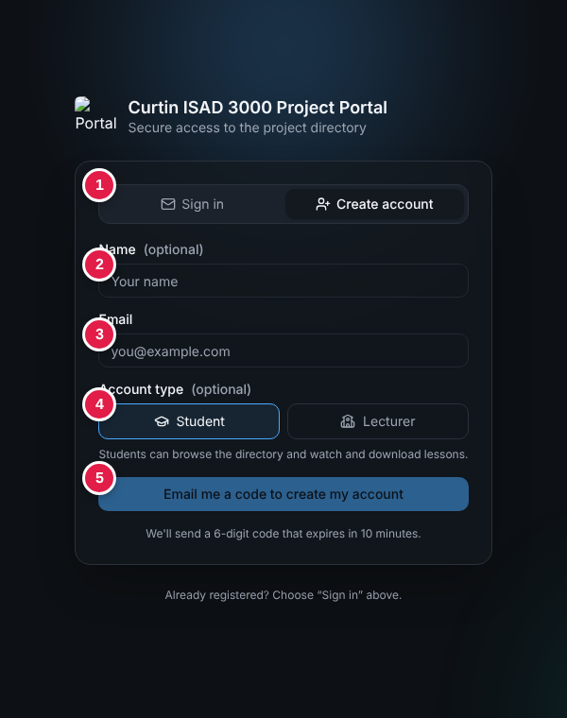
Create account tab
Role | What they can do
Student (default) | Search and filter projects, read details, browse lessons, watch videos, download documents.
Lecturer | Everything a student can, plus add lessons (documents, video file, YouTube link) and delete lessons.

3.2 Who can become a lecturer
A person gets the Lecturer role only if they ask for it when creating the account and their email is approved: listed with the role Lecturer in data/users.json, or listed in the LECTURER_EMAILS setting. Otherwise the account is created as a Student and the person sees "Lecturer access needs approval. Ask the portal owner to add your email as a lecturer."
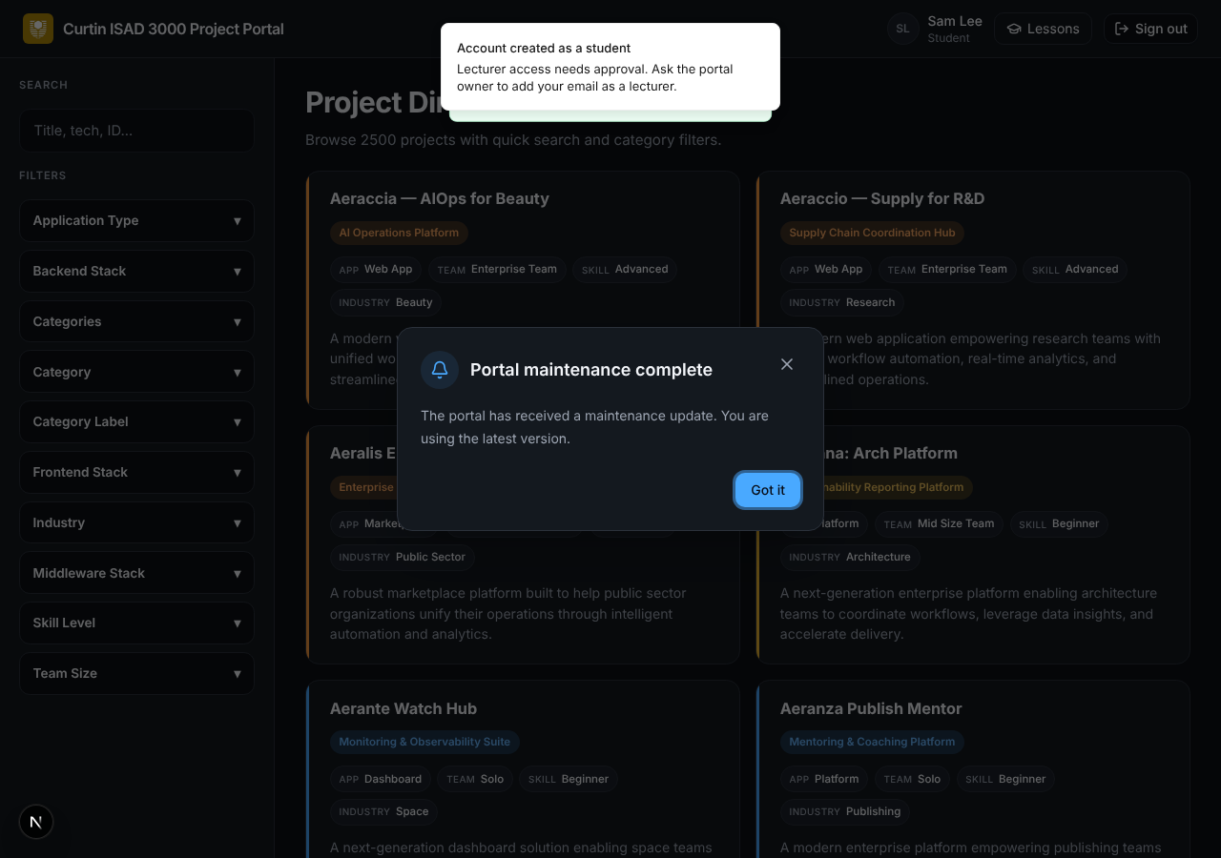
Unapproved lecturer request: created as a student

3.3 Add or approve someone
- Add the person's email to ALLOWED_EMAILS (or remove it to block them from getting codes).
- To approve a lecturer, add the email to LECTURER_EMAILS (or give the person the role Lecturer in data/users.json) before they create their account, then redeploy.
- Ask the person to open Create account, choose Lecturer and finish with the code.
- Check the header shows the role Lecturer and the Lessons page has Add lesson.
WARNING
The Portal cannot change the role of an account that already exists. If someone created a Student account by mistake, an administrator must change the role in the database (users table) or remove the account row so they can register again.

4. Sign-in email
- Set one email method (Resend key or SMTP details) and EMAIL_FROM.
- Request a code for a test address; the email "Your Capstone Portal sign-in code" should arrive within a minute.
- If no email is configured, codes are only printed in the server log - fine for development, not for live.

5. Announce maintenance (maintenance notice)
- Open data/maintenance-notice.json.
- Change id to a new unique value, for example 2026-11-05-portal-maintenance. The same id as before means nobody sees it again.
- Change title (short) and message (one or two sentences).
- Save, run npm test, and deploy.
- Sign in as a user who has not seen it and confirm the dialog appears; click Got it and confirm it does not return.
Field | Example
id | 2026-10-23-portal-maintenance
title | Portal maintenance complete
message | The portal has received a maintenance update. You are using the latest version.
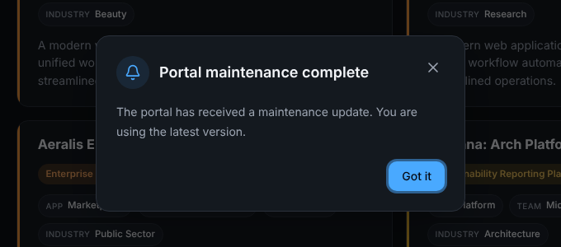
What users see

6. Manage lessons
Lessons are managed in the Portal itself by lecturers; no file editing or release is needed. Everything is stored in the database (tables lessons and lesson_files).

6.1 Add a lesson (lecturer)
- Sign in with a Lecturer account and open Lessons.
- Click Add lesson and enter a title (required), an optional section such as "Module 3", and a description.
- Add a YouTube link, a video file (.mp4 or .webm up to 20 MB) and/or up to five documents (10 MB each).
- Click Save lesson. "Lesson added." appears and the lesson is listed first for everyone.
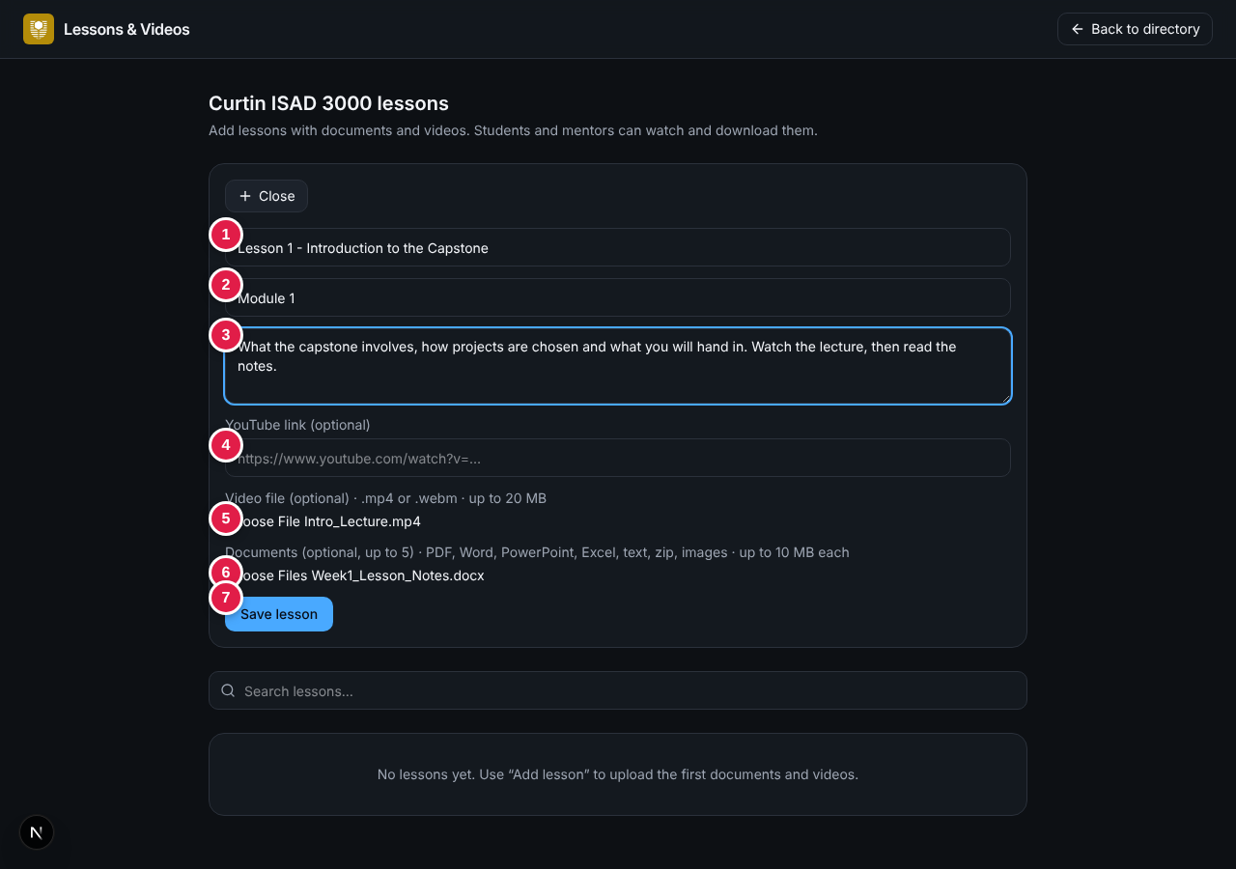
Add lesson form

6.2 Delete a lesson
Click the trash button on the lesson and confirm. The lesson and all its files are removed for everyone and cannot be recovered.
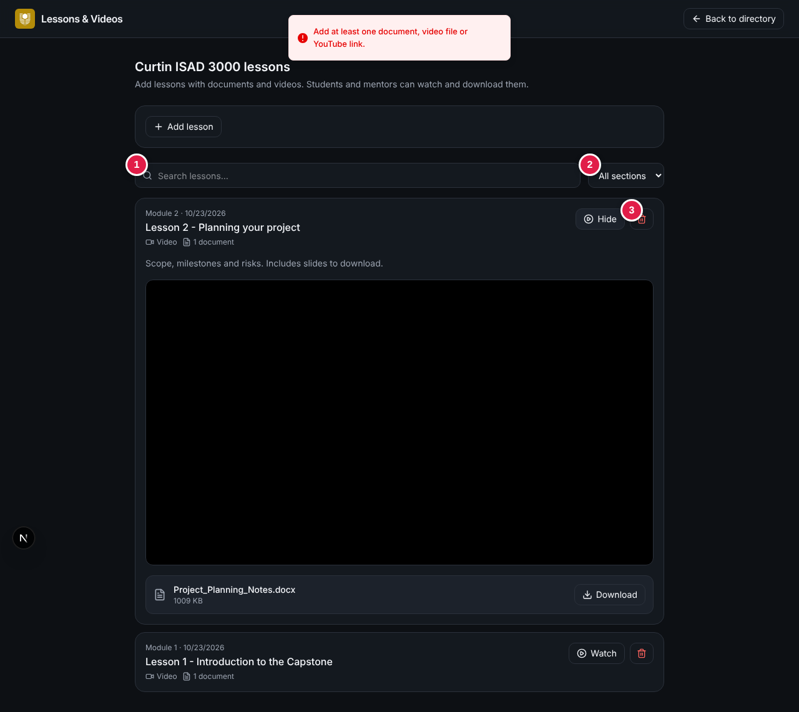
Lecturer view with delete buttons (3)

6.3 Limits and storage
Item | Limit
Documents | Up to 5 per lesson, 10 MB each; PDF, Word, PowerPoint, Excel, text, Markdown, zip, PNG, JPEG
Video file | One per lesson, .mp4 or .webm, up to 20 MB. For longer videos use a YouTube link.
Where files live | Inside the database as binary data - the database grows with every upload
Hosting | A read-only host cannot save lessons; set DATABASE_URL and DATABASE_AUTH_TOKEN to a writable libSQL / Turso database
TIP
Back up the database before large clean-ups; deleted lessons cannot be restored from the Portal.

7. Deploy a change
Step | Action
1 | Make the change on a branch (data file edits are changes too).
2 | Run npm run check (type check, lint, tests, build). Fix anything that fails.
3 | Push. GitHub Actions ci repeats the checks.
4 | Check the change at the test address.
5 | Run the promote workflow to release to live.
6 | Confirm live with the quick checks in section 8.
Hosting options: Vercel or any Node host (npm run build, npm start), or Cloudflare Workers through vinext (npm run build:vinext, npm run deploy:vinext). Set all environment variables in the host before the first release.

8. Routine checks
Check | How | Expected
Health | Open /api/health | A success response.
Create account | Create an account with an approved email | "Account created. Welcome!"
Sign-in (student) | Sign in with an existing student account | Email arrives; code signs in.
Sign-in (lecturer) | Sign in with a lecturer account | Header shows Lecturer.
Directory | Sign in | "2500" shown; search and filters work.
Lessons | As lecturer add a test lesson, as student watch and download, then delete it | Each step works.
Notice | First sign-in after a new id | Dialog appears once.
Smoke test | npm run test:smoke | Passes.
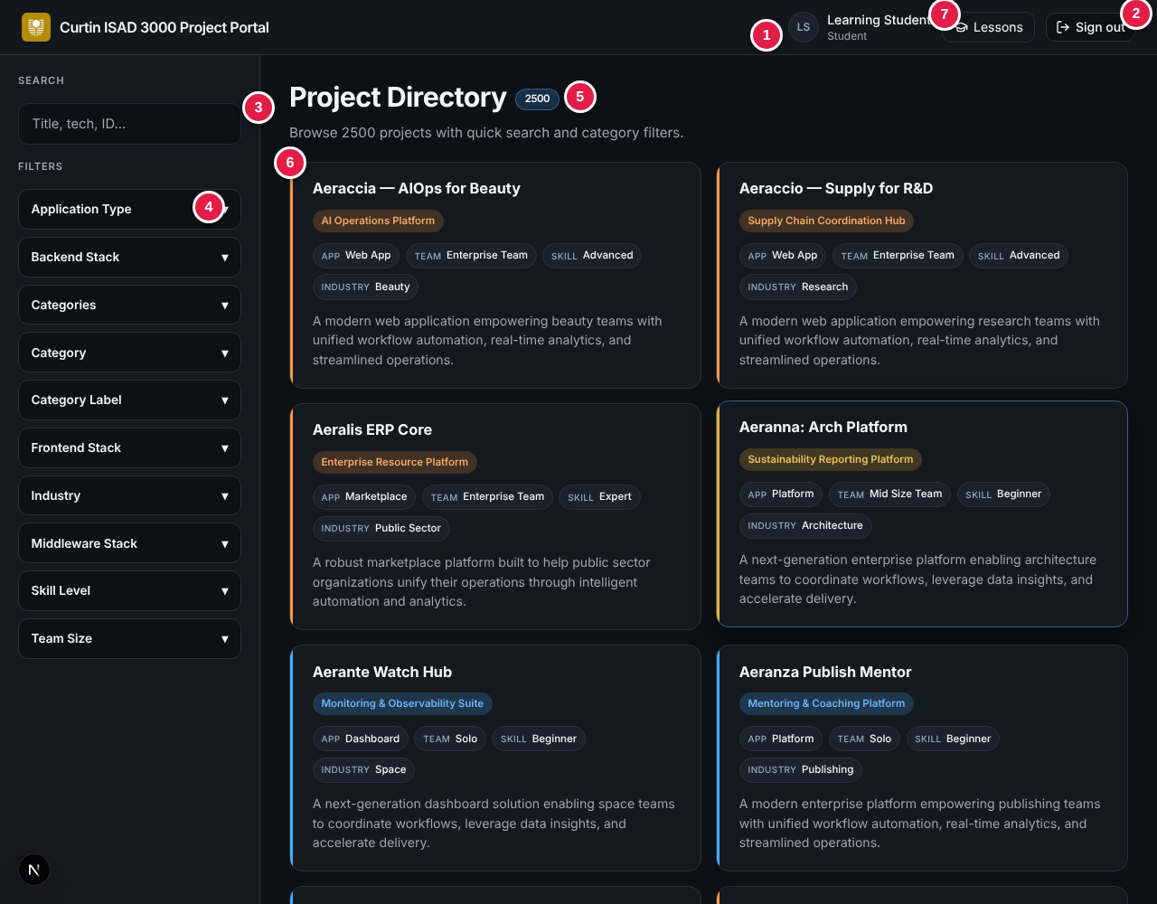
Directory after a successful release

9. Troubleshooting
Problem | Likely cause | Fix
"Server error" at sign-in | SESSION_SECRET missing or too short | Set it (16+ characters) and redeploy.
No sign-in email | No email method, wrong credentials, address not approved, spam folder | Check settings, ALLOWED_EMAILS and the provider log.
"No account found for that email" | Account not created yet | Use the Create account tab.
"Account created as a student" | Email not approved as lecturer | Add it to LECTURER_EMAILS or data/users.json, then change the role in the users table or recreate the account.
"Could not save the account (database is read-only)" | No writable database | Set DATABASE_URL and DATABASE_AUTH_TOKEN.
No Add lesson button | Account is a Student account | Approve the email and fix the account role (see 3.2).
Lesson will not save (error with database hint) | Database read-only or not configured | Set DATABASE_URL and DATABASE_AUTH_TOKEN.
"The video is larger than 20 MB" | File over the limit | Upload to YouTube and paste the link.
Lessons vanish after a redeploy | Local file database used on a host that resets its disk | Use a hosted libSQL / Turso database.
Everyone is sent back to sign-in | SESSION_SECRET changed | Expected after a change; users sign in again.
Notice does not appear | Same id already dismissed | Use a new id.
Logo missing on sign-in page | Route guard blocks /logo.png | Exclude the logo path in proxy.ts.

10. Security reminders
- Use a unique SESSION_SECRET per environment and rotate it if it may have been shared. The sample .env.example holds a realistic value - replace it with a placeholder and rotate the live secret.
- Never enable AUTH_DEV_ECHO on live.
- Keep ALLOWED_EMAILS and LECTURER_EMAILS up to date; remove people who leave the course.
- Never commit .env.local or provider keys.

11. Related documents
Document | ID
Software Requirements Specification | CP-SRS-001
User Acceptance Testing | CP-UAT-001
User Guide | CP-UG-001
Login Guide | CP-LG-001
Release Notes | CP-RN-001
Technical Design and Architecture | CP-TDD-001

